**Module 7: Final Research Paper**

Kevin Min

Colorado State University Global

Course Code: MIS581-1

Dr. Steve Chung

May 7, 2023

**Abstract**

The research is on the relationship between Federal Funds Rate and imported oil prices. The study finds that there is a statistically significant negative relationship between real oil prices and the federal funds rate. Specifically, an increase in real oil prices is associated with a decrease in the federal funds rate, and vice versa. However, it is not a strong relationship. The findings suggest that changes in federal funds rates or monetary policy decisions can have a significant impact on oil prices.

The study also finds that there is a statistically significant regression between oil prices, predictor valuable, and federal funds rate, predicted value. However, the regression models are not strong predictors as they have very low R-squared values. Regardless, despite the not strong relationships between such variables, it could be used as further research to see if the model could be a better predictor.

Overall, this study highlights the importance of considering the relationship between real oil prices and the federal funds rate when analyzing the macroeconomic performance of the U.S. economy. The findings have implications for policymakers, investors, and businesses, and can help inform decision-making in the energy and financial sectors.

Contents

**Introduction** 4

**Objective** 5

**Overview of Study** 5

**Dataset Description** 6

**Data Analytics Tools Used to Analyze the Dataset** 7

**Type of Variables** 7

**Research Questions and Hypotheses** 9

**Literature Review** 9

**Research Design** 11

**Methodology** 11

**Methods** 11

**Limitations** 12

**Ethical Considerations** 12

**Findings** 12

**Conclusion** 19

# **Introduction**

Interest rates and oil prices are two critical economic indicators that have been the topic of economic research. The relationship between the two has been a subject of interest among academics, policymakers, and investors alike. The oil industry is one of the most volatile sectors of the economy as it influences many sectors (Azad & Serletis, 2022). On the other hand, Federal Funds Rates (FFR) are a critical tool for central banks to manage inflation and promote sustainable economic growth.

Fuel is a critical input for many high-demand commodities around the world (Kosakowski, 2008). Transportation, industrial, and residential sectors are the biggest sectors for using oil. Oil prices are usually set by global supply and demand (Kosakowski, 2008). If the demand goes up or if the supply decreases, then the prices will increase in reaction. If the demand goes down or the supply increases, then the price decreases. The production cost is another factor, as there are other inputs involved in oil that may have a domino effect.

Consumer interest rates are dependent on the FFR. The Federal Open Market Committee (FOMC) discusses and votes on what target interest rate to set (Diatkine, 2013). Commercial banks borrow money at this FFR or interest rate and lend their excess funds to one another. The FFR has an impact on borrowing costs and financial conditions, so stock markets are sensitive to the rates (Diatkine, 2013). The FFR indirectly impacts short-term interest rates. The FOMC raises the FFR to combat inflation and decreases it to combat a recession.

The goal is to analyze the connection between FFR and oil prices using empirical analysis. The FFR can change in response to economic changes, and oil prices can be volatile. The main purpose is to see if there is a correlation between oil prices and the FFR. The purpose is also to determine if oil prices and FFR have a linear relationship. These three questions are related to the core problem:

* What is the relationship between FFR and oil prices?
* How do changes in FFR impact oil prices?

# **Objective**

The primary goals are to provide a comprehensive analysis of the connection between FFR and oil prices. It is also to analyze the impact of changes in FFR on oil prices and vice versa. The results can provide insights into how policymakers, investors, and businesses can use the findings of this research to make informed decisions.

The research will also identify the factors that influence the relationship between these two economic indicators, such as inflation, GDP growth, and geopolitical events (Kilian & Zhou, 2022). Another goal is to see if this can be added to the discussion on whether countries should be less dependent on oil and use other sources of energy. Interest rates are always part of a country’s management of money, whether it's in the public or private sector. If central banks also use interest rates to combat recession and inflation, then it could be a further discussion to see if countries should stray away from oil usage as they need interest rates in their economies. This situation is a possible topic of discussion if there is a linkage between FFR and oil prices.

# **Overview of Study**

The study focuses on investigating the connection between oil prices and FFR. The study will use correlation and linear regression analysis. The study utilizes quantitative research methodology, utilizing time-series data. The study aims to assess the strength and direction of the correlation between oil prices and FFR through correlation analysis and estimate the quantitative relationship between the two variables using linear regression analysis.

The study utilizes historical data on oil prices and the FFR to conduct a quantitative analysis. The study begins by conducting descriptive statistics to analyze the trends, patterns, and characteristics of the data. This will include means, standard deviations, and correlations to provide an initial understanding of oil prices and the FFR connection. Subsequently, a linear regression analysis is conducted to see if the oil prices have an impact on the FFR.

The output or dependent variable is the FFR, which is the predicted variable once the model is fitted. The independent variable is the oil price, which is the variable that is used to explain the changes in the FFR. The regression equation is formulated as follows:

FFR = β0 + β1 * Oil Price + ɛ

Where:

FFR: The dependent variable representing the FFR.

Oil Price: The independent variable representing the oil price.

β0: The intercept term

β1: The slope coefficient, which represents the change in the FFR for a one-unit change in the oil price.

ɛ: The error term captures the unexplained variability in the FFR that is not accounted for by the oil price.

# **Dataset Description**

The datasets are monthly average oil prices and interest rates from January 2000 to January 2023. The U.S. Energy Information Administration's (EIA) imported crude oil price represents the oil prices, while the Federal Funds Rate (FFR) represents the interest rates. The crude oil price was obtained from the EIA website (EIA,2023). The data contains 612 observations from 1972 to 2024. It also contains projected information, hence the reason it goes up to 2024. There are four variables, or columns, so there are a total of 8096 observations. The data was last updated in March 2023. The FFR data was obtained from the Federal Reserve Economic Data (FRED) database. The Federal Reserve Bank of St. Louis maintains the FRED (Board of Governors of the Federal Reserve System (US), 2023). The dataset contains 277 observations for each variable, making a total of 554 observations. The data was last updated in March 2023.

# **Data Analytics Tools Used to Analyze the Dataset**

The data analytics tools used to analyze the dataset are Microsoft Excel and SAS. SAS is used to create basic charts and graphs that visually represent the relationship between oil prices and interest rates. Before I import the data to SAS, I will normalize or clean the data in Microsoft Excel. For example, if they use a character for 0 instead of the numeric type I will also check to make sure the data is in a consistent format for both the imported crude oil price dataset and the FFR data set. I will make sure the numeric values are in the numeric type and not in the character type in Excel. I will also do a quality check in SAS after I import the Excel files to make sure the formats are consistent with the data sets.

SAS is used to perform advanced statistical analysis, such as linear regression analysis, which is used to model the relationship between oil prices and interest rates. SAS will also be used to do a series of tests on the regression or model of the variables to see if they are suitable for usage or deployment. SAS is also used to create data visualizations, such as scatter plots and histograms, that help visually represent the relationship between oil prices and interest rates (Nguyen et al., 2020). SAS will be used to do statistical tests to test hypotheses and determine if the relationship is statistically significant.

# **Type of Variables**

The variables in the dataset are continuous interval variables. Even though the dates can be identified as continuous, they can also be identified as discrete. For this example, we have identified the dates as continuous. The dates are in a month-year format, with the first day of the month for each of the entries. For the FFR dataset, there are only dates, and the FFR is measured in percentage points.

In the oil price data set, there are also consumer price index (CPI) data values that are numerical. A consumer price index measures a market basket of goods and services that households have bought at a weighted average price. The measured CPI fluctuates to reflect variations in prices over time. In addition, in the oil price data set, the imported crude oil prices are measured in dollars per barrel. There are two types of imported crude oil prices: nominal prices and real prices. The nominal price is the face value price of the imported crude oil price without taking inflation into the price at that corresponding date. The real price is the relative price after inflation is accounted for. It usually involves adjusting the nominal price with the CPI for that time frame to get the real price. The base CPI has a value of 3.022. The real price is calculated based on multiplying the nominal price by the base CPI. The result from that equation is divided by the CPI value of that corresponding date to get the real price for the imported crude oil. Both variables can take any value within a range of values.

**Figure 1**

*Data Dictionary of Oil Price and Federal Funds Rate*

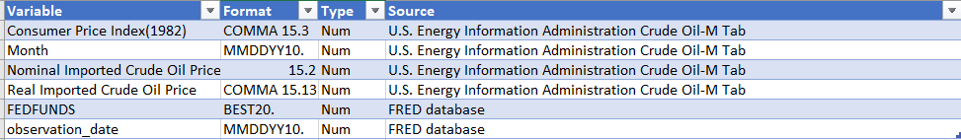

# **Research Questions and Hypotheses**

The key point is to see if an increase in the increase rate will increase or decrease the oil point and how much of a change it will make. It is also an opportunity to examine the relationship across periods. So, some of the questions to ask to examine this relationship are:

* What is the direction and strength of the relationship between oil prices and FFR?
* What is the FFR influence on oil prices?

The null hypothesis is zero correlation or relationship between oil prices and interest rates. The alternative hypothesis would be that there is no correlation or relationship between these variables. The following hypotheses will be examined in this project:

* Ho: No significant relationship exists between oil prices and the FFR.
* Ha: There is a significant relationship between oil prices and the FFR.

The hypothesis that there is a significant connection between these two variables is important to test.

The null hypothesis in this context would be that the slope is 0 or that FFR is not useful for making predictions of oil prices. The alternative hypothesis would be that the slope is not 0 and the FFR is used for making predictions of oil prices. The following hypotheses will be examined in this project:

* Ho:β1=0
* Ha: β1≠0

# **Literature Review**

Hong, Wang, and Zhang (2017) investigated the link between oil prices and inflation in the United States. The authors employed an empirical approach, specifically a Vector Autoregression (VAR) model, to analyze the time-series data from 1986 to 2016. Their findings revealed a statistically significant positive relationship between oil prices and U.S. inflation. It means that changes in oil prices can impact inflation in the U.S. economy over the long run.

Wu, Yang, and Tian (2019) conducted a study on the relationship between oil prices, exchange rates, and agricultural commodity prices. The authors utilized an econometric approach, employing a vector error correction model (VECM) to analyze the time-series data from multiple countries. Their findings indicated that oil prices and exchange rates had significant impacts on the prices of agricultural commodities, suggesting that changes in oil prices and exchange rates can affect the prices of agricultural commodities in both the short and long run.

Omay and Kanar (2016) examined the interplay between the FFR and crude oil prices. The authors employed a time-varying parameter vector autoregressive (TVP-VAR) model to analyze the data spanning from 1986 to 2015. Their findings revealed a dynamic relationship between the FFR and crude oil prices, with changes in the FFR affecting crude oil prices differently during different periods, indicating the importance of considering time-varying dynamics in understanding the relationship between monetary policy and oil prices.

Mohammadi and Su (2017) conducted a study on the relationship between monetary policy and crude oil prices using wavelet analysis. The authors employed a wavelet-based approach to analyze the time-frequency dynamics between monetary policy variables and crude oil prices, using data from the United States spanning from 1990 to 2015. Their findings revealed significant time-based relationships between monetary policy and crude oil prices. It has evidence for both short-term and long-term connections, indicating that monetary policy can have an impact on crude oil prices at different time scales.

# **Research Design**

## **Methodology**

The research design for studying the correlation between oil prices and FFR typically involves quantitative research using time-series data. Data on oil prices were collected from 1972 to 2023. The crude oil price was obtained from the U.S. Energy Information Administration's (EIA) website (EIA, 2023). The data contains 612 observations from 1972 to 2024. It also contains projected information, hence the reason it goes up to 2024. There are four variables, or columns, so there are a total of 8096 observations. The data was last updated in March 2023. The FFR data was obtained from the Federal Reserve Economic Data (FRED) database. The Federal Reserve Bank of St. Louis maintains the FRED (Board of Governors of the Federal Reserve System (US), 2023). The dataset contains 277 observations for each variable, making a total of 554 observations. The data was last updated in March 2023. The datasets are monthly average oil prices and interest rates from January 2000 to January 2023. The type of research is quantitative, as it involves numerical data for analysis.

## **Methods**

The research design may involve using statistical techniques such as correlation analysis and linear regression analysis. Correlation analysis is used to assess the strength and direction of the association between oil price and FFR, typically using measures such as Pearson's correlation coefficient or Spearman's rank correlation coefficient (Stevens, 2007). Linear regression analysis is used to estimate the quantitative relationship between oil price and FFR, with regression models used to estimate the slope of the regression line.

## **Limitations**

There are several limitations to consider in the research design. Firstly, a correlational research design does not establish causality. This means that the correlation between oil prices and FFR does not necessarily imply a cause-and-effect relationship. Additionally, the research design is based on historical data and thus may be subject to limitations such as data accuracy, reliability, and potential confounding variables. The limitations of linear regression analysis should also be considered, such as assumptions of linearity, homoscedasticity, and normality.

## **Ethical Considerations**

We must ensure that their personal information is used only for the specific purpose it was collected for. When it comes to using data to determine oil prices and the federal funds rate, there are important ethical considerations that must be considered. One important ethical consideration is making sure the data we use is accurate and unbiased (Kisselburgh & Beever, 2022). If the data is inaccurate or is being manipulated, this can lead to incorrect conclusions and decisions that could harm people or society. Another ethical consideration is protecting the privacy of individuals whose data is being used (Kisselburgh & Beever, 2022). We must ensure that their personal information is used only for the specific purpose for which it was collected.

# **Findings**

Figure 1 has the oil price and FFR in one graph where the y-axis on the left corresponds to the oil price while the y-axis corresponds to the FFR percentage. The FFR increased above 6 percent before 2001 then it decreased to less than 2 percent in 2002. It goes up from 2004 to about 2007 then it declines until 2008 when it remains close to 0%. It rises again from 2016 to 2019 and it drops until 2022. It rises back up from 2022. Oil prices seem to increase from 2000 to 2007 and then decline. It goes back up until 2-12 and then from 2014 to 2016, it drops. It hits a low point in 2020 and goes back up until it gets to 2022.

**Figure 1**

*Historical trend of FFR and Real Crude Oil Prices 2000-2023*

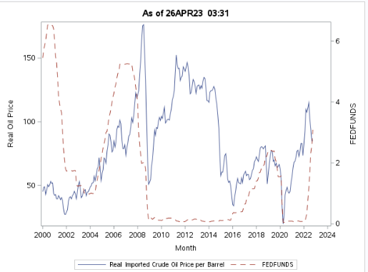

The mean of real imported crude oil price per barrel is 80.1, greater than the median of 72.74. The FFR’s mean is 1.62, greater than the median of 1. Both imply that they are a positively skewed distribution. The FFR also seemed to have a couple of outliers as noted by the box plot. The distribution of FFR is highly skewed as future studies can look into doing a logarithmic transformation of the distribution to see if it will be normal.

**Figure 2**

*Summary statistics, histogram, and boxplots of FFR and Real Crude Oil Prices 2000-2023*

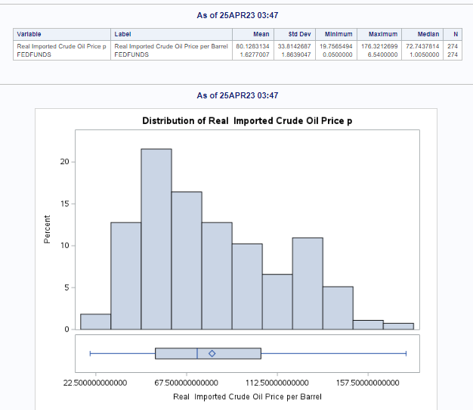 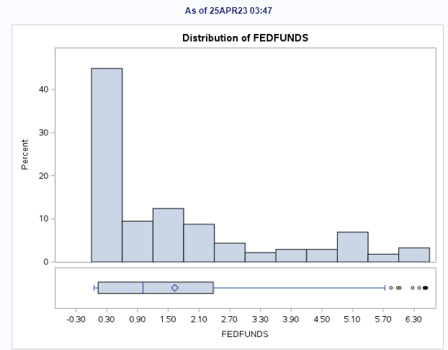

The correlation between FFR and real imported oil price is -0.21, meaning there is an inverse relationship between the two variables. The p-value is less than 5% suggesting that it is statically significant. There is a negative correlation in which when the FFR goes up, then the oil prices go down or vice versa but it is a very weak correlation. The scatter plot matrix does not show a visual of a linear trend between the two variables, supporting the notion that it is a weak negative correlation.

**Figure 3**

*Correlation analysis of FFR and Real Crude Oil Prices 2000-2023*

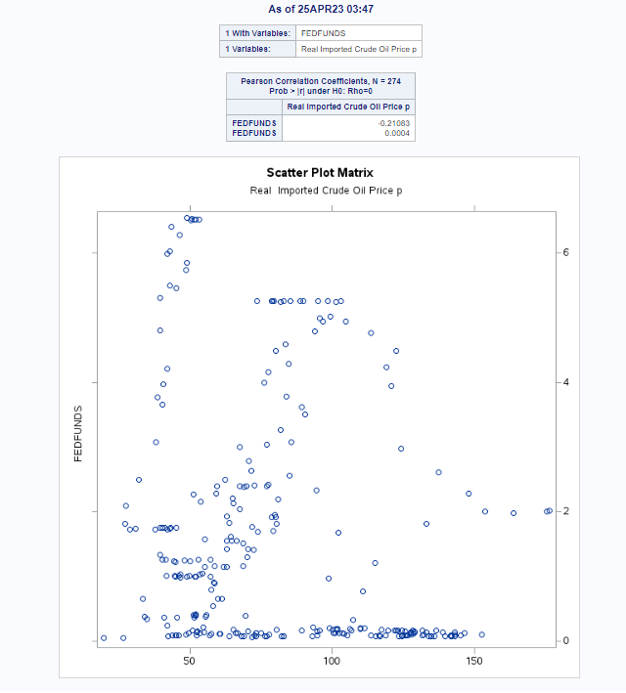

For Figure 4, I created two linear models. One is where the real oil price is the predictor and FFR is the predicted variable. Realoil=86-3.82(FFR). The second model is in addition the months as an independent variable which outputted Realoil=67.4+0.00009(month)-3.14(FFR). Both models have a low F-value and a P-value less than 5% suggesting that there is a relationship between the variables but not a strong one due to the low F-value. The R2 for both models are very low at 0.04 suggesting that they are not great predictors.

**Figure 4**

*Linear analysis of FFR and Real Crude Oil Prices 2000-2023*

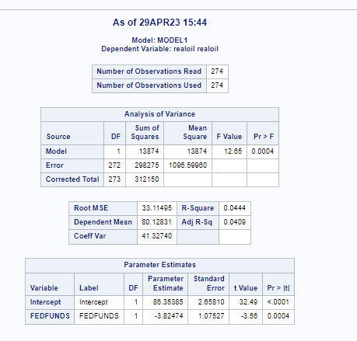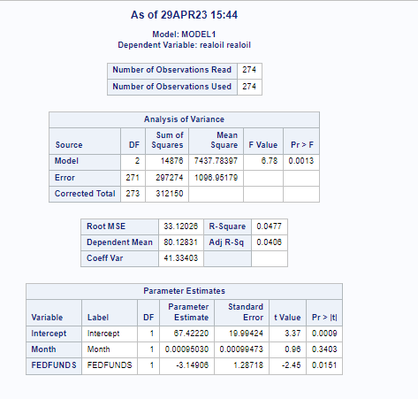

For Figure 5, I modeled based on using lag as a factor for oil prices and FFR. The high SSE of 9711 suggests that the model is not a good fit. The lag is based on one month or past period of the respective independent variable. Using a regression equation to predict the present values of a dependent variable based on both the current values of an explanatory variable and the lagged (past period) values of this explanatory variable is known as a distributed lag model (Stevens, 2007). The MSE of 36 suggests that the forecast is close to the actual as the value is closer to 0, which means that the predicted values match the actual value. The R-square of 97% suggests that the FFR or predicted value can be explained by its predictor variables greatly. The Granger test on the right shows that both test statistics are not statistically significant at the 5% level. It would seem that past values of FFR would not be a good aid in predicting real oil prices.

**Figure 5**

*Linear analysis of FFR and Real Crude Oil Prices 2000-2023 with lag as a factor*

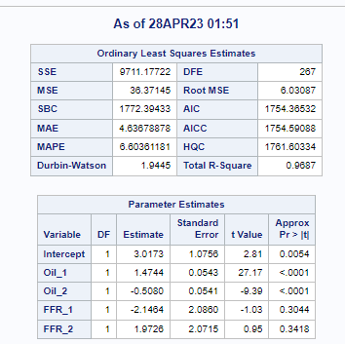 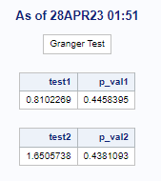

For Figure 6, I did a Multivariate time series analysis using the regression with a vector autoregressive model. The model output is realoil=1.91+0.14(FFR(t))+0.97(realoil(t-1)). The p values for the intercept and FFR coefficient do not suggest that they are statistically significant. However, the real oil (t-1) suggests that it is statistically significant.

**Figure 6**

*Multivariate Time series analysis of FFR and Real Crude Oil Prices 2000-2023*

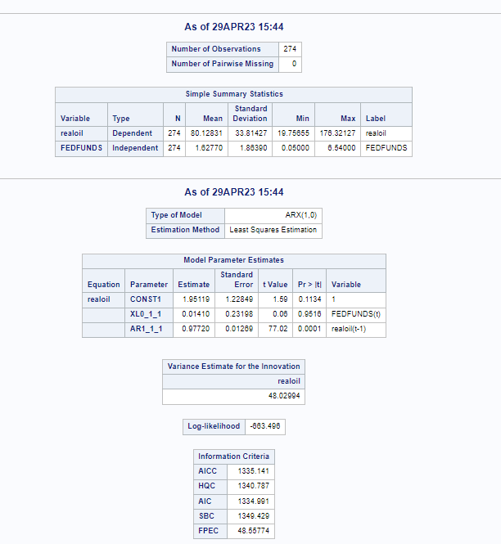

The correlation analysis p-value suggests that there is a statistically significant correlation between FFR and real oil prices. We reject the null hypothesis that there is no correlation between real oil prices and FFR. However, the correlation value is so low that there is not a strong negative or inverse relationship between oil real prices and federal funds rates.

In terms of the second hypothesis, the slope p-values are less than 5% suggesting that we can reject the null hypothesis. The exception is the time series model and the model using lags as a factor. However, the overall models across all models are not great predictors.

I created four models to see if there are different results and to see if one model is a better model than the other. Using AIC as a criterion, the fourth model where the month is used as a time series in Figure 6 or the time series analysis is the best model. If we were to use the lowest SSE, the model where I used two lags for FFR and oil prices is the best model. This model also has the highest R-squared among the models. In terms of the ideal model selection, the model with lags as a factor is the better model.

# **Conclusion**

The study tested two hypotheses regarding the relationship between oil prices and FFR. The outcome is that the identified null hypothesis was rejected. The caveat is that the models are not great predictors.

The study's findings imply that variations in FFR may affect oil prices; however, this effect is not statistically significant. This has significant ramifications for investors and policymakers since changes in these factors can have an impact on the world economy by altering borrowing costs and investment choices.

Future studies can be done to see if FFR data could be transformed using the log distribution or other distributions while running Monte Carlo simulations to see if it becomes a normal distribution (Stevens, 2007). Another option is to see if oil prices can be the predictor value and FFR the predicted value in the regression modeling.

In sum, this study emphasizes how crucial it is to consider the link between federal funds rates and oil real prices to comprehend the global economy. Policymakers and investors can make better choices about energy policy and investments in the energy industry by looking at the variables that affect this relationship.

**References**

Azad, N. F., & Serletis, A. (2022). Oil Price Shocks in Major Emerging Economies. *Energy Journal*, *43*(4), 199–213. <https://doi.org/10.5547/01956574.43.4.naza>

Board of Governors of the Federal Reserve System (US). (2023, March 31), Federal Funds Effective Rate

[FEDFUNDS], retrieved from FRED, Federal Reserve Bank of St. Louis. Retrieved April 1, 2023 from https://fred.stlouisfed.org/series/FEDFUNDS/

Clerides, S., Krokida, S.-I., Lambertides, N., & Tsouknidis, D. (2022). What matters for consumer

sentiment in the euro area? World crude oil price or retail gasoline price? Energy Economics, 105. <https://doi.org/10.1016/j.eneco.2021.105743>

Diatkine, S. (2013). Monetary policy on interest rates: a retrospective analysis since Thornton. European Journal of the History of Economic Thought, 20(5), 715–740. <https://doi.org/10.1080/09672567.2011.653881>

Hong, T., Wang, J., & Zhang, H. (2017). The relationship between oil price and U.S. inflation. Energy

Economics, 61, 41-48.

Ider, G., Kriwoluzky, A., Kurcz, F., & Schumann, B. (2023). And Yet They Move: Energy Prices Fall When

Key Interest Rates Increase, Despite Countervailing Effects. DIW Weekly Report, 13(8), 74–80. <https://doi.org/10.18723/diw_dwr2023-8-1>

Kilian, L., & Zhou, X. (2022). Oil prices, exchange rates, and interest rates. Journal of International Money

and Finance, 126. <https://doi.org/10.1016/j.jimonfin.2022.102679>

Kisselburgh, L., & Beever, J. (2022). The ethics of privacy in research and design: Principles, practices,

and potential. Modern Socio-Technical Perspectives on Privacy, 395-426. <https://doi.org/10.1007/978-3-030-82786-1_17>

Kosakowski, P. (2008, July 2). What determines oil prices? Investopedia.

<https://www.investopedia.com/articles/economics/08/determining-oil-prices.asp>

Mohammadi, H., & Su, L. (2017). Monetary policy and crude oil prices: Empirical evidence from the wavelet analysis. Energy Economics, 65, 98-110.

Nguyen, Q. V., Miller, N., Arness, D., Huang, W., Huang, M. L., & Simoff, S. (2020). Evaluation of

interactive visualization data with scatterplots. Visual Informatics, 4(4), 1–10. <https://doi.org/10.1016/j.visinf.2020.09.004>

Omay, T., & Kanar, D. (2016). The dynamic relationship between the Federal funds rate and crude oil

prices. Energy Economics, 54, 417-427.

Ranganathan, P., & Cs, P. (2019). An Introduction to Statistics: Understanding Hypothesis Testing and

Statistical Errors. Indian Journal of critical care medicine : peer-reviewed, official publication of Indian Society of Critical Care Medicine, 23(Suppl 3), S230–S231. <https://doi.org/10.5005/jp-journals-10071-23259>

Stevens, J. P. (2007). Intermediate statistics: A modern approach. Routledge.

O’Leary, Z. (2021). The Essential Guide to Doing Your Own Research Project. Sage Publications.

U.S. Energy Information Administration (EIA) (2023). Short-Term Energy Outlook. Retrieved April 1, 2023

from https://www.eia.gov/outlooks/steo/realprices/

Verbeek, M. (2017). Using linear regression to establish empirical relationships. *IZA World of Labor*.

<https://doi.org/10.15185/izawol.336>

Wu, Y., Yang, Z., & Tian, S. (2019). Oil price, exchange rate, and the price of agricultural commodities.

Energy Economics, 80, 743-752.